1. Now we have a problem where we are not able to persist files/data permanently when a container saves it and the container is removed and another container is not able to see those files/data.
2. **Solution**: **Volumes**: To persist data.
3. Let’s understand volumes.  
   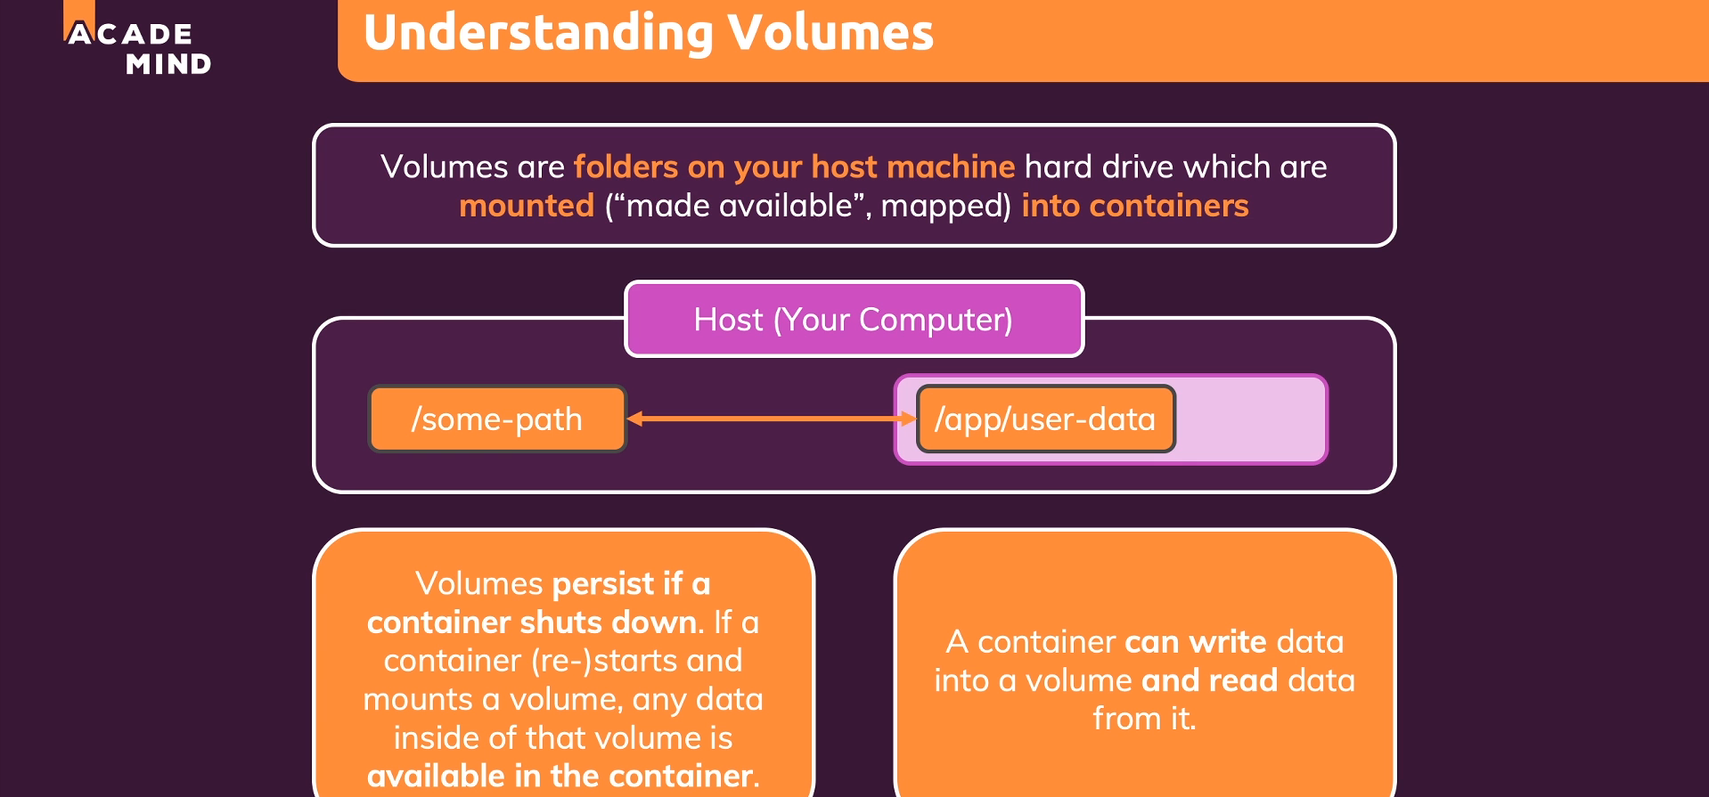
   1. Changes in either folder (on host machine or inside container) will be reflected in the other one.
   2. Actually, **volume** serves two purposes.
      1. To persist data/file permanently regardless of container.
      2. To access container’s folder outside the container from the host machine.